+44 (0)333 321 8811
enquiries@bregroup.com
redbooklive.com
BRE Global
Bucknalls Lane
Watford, Herts
WD25 9XX



LOSS PREVENTION STANDARD

LPS®1531: Issue 2.0

Requirements for the LPCB approval and listing of companies installing or applying passive fire protection products
Date: June 2024
Status: Final Draft
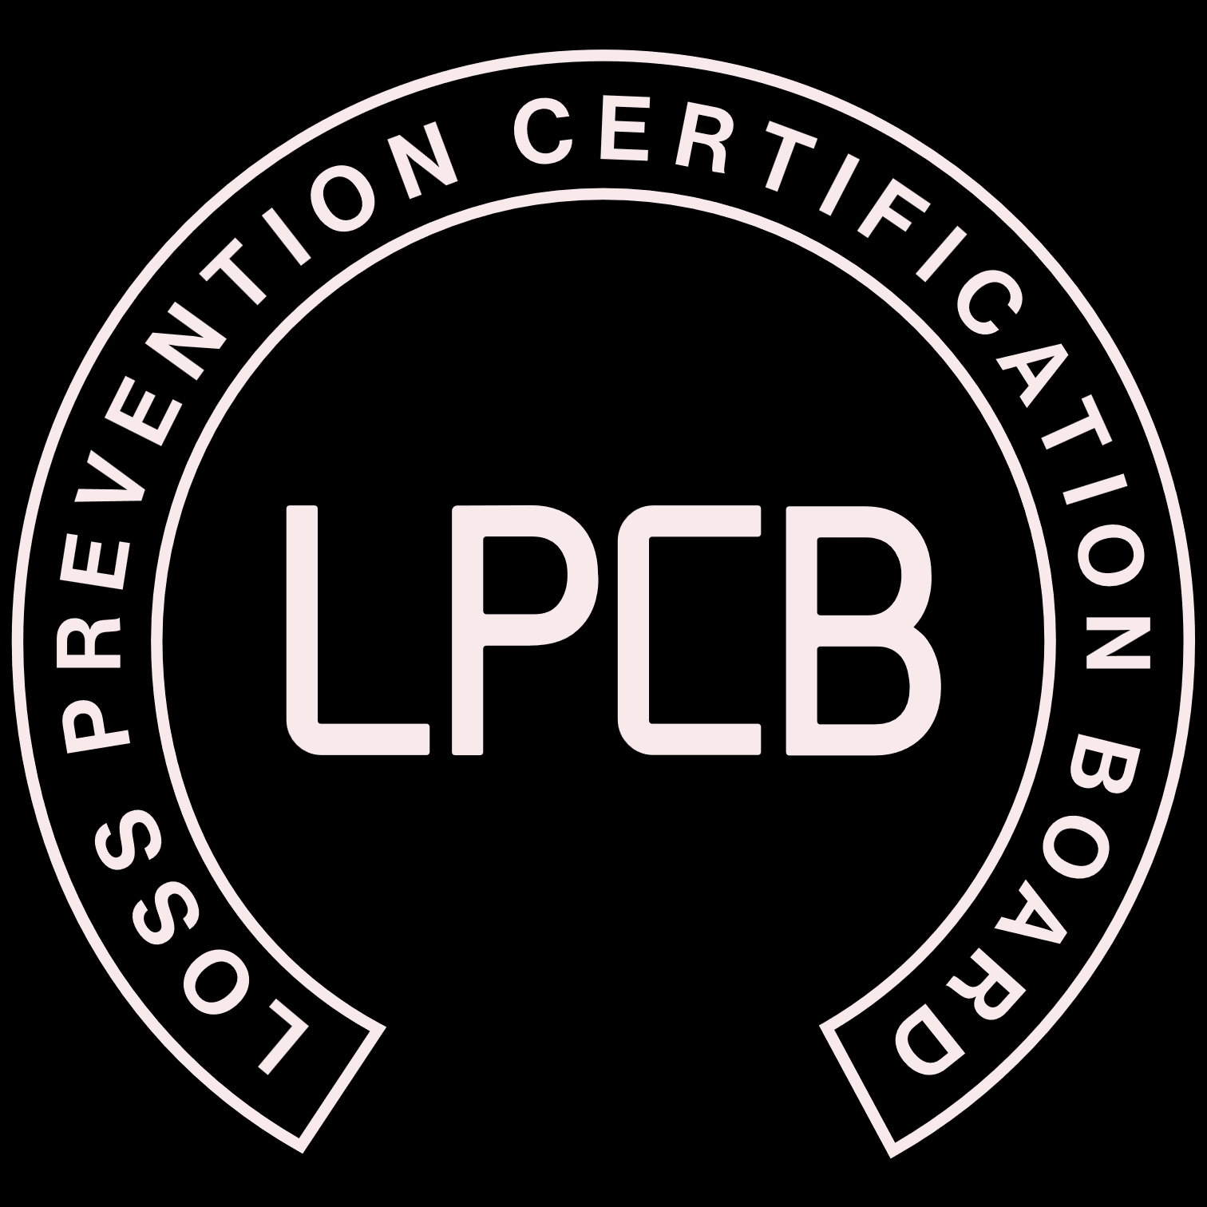

redbooklive.com

This Loss Prevention Standard is the property of BRE Global and is made publicly available for information purposes only. Its use for testing, assessment, or certification must be in accordance with LPCB internal procedures and requires interpretation by BRE Global, LPCB and BRE experts. Any party wishing to use or reproduce this Loss Prevention Standard to offer testing, assessment, or certification must apply to BRE Global for training, assessment and a licence; a fee will normally be charged. BRE Global will not unreasonably refuse such applications. BRE Global accepts no responsibility for any unauthorised use or distribution by others of this Loss Prevention Standard and may take legal action to prevent such unauthorised use or distribution.
Page

Table of Contents
Participating Organisations 4
Revision of Loss Prevention Standards 5
Foreword 6
1. Scope 7
2. Definitions 7
2.1 Installing Company 7
2.2 Approved Installer 7
2.3 CSCS (Construction Skills Certification Scheme) 7
2.4 National Vocational Qualification 7
2.5 Scottish Vocational Qualification 7
2.6 Workmanship 7
2.7 Site Audit 7
2.8 Office Audit 7
2.9 Management System 7
2.10 LPCB 7
2.11 Minor and Major Non-conformances (NCR’s) 7
3 Requirements 8
3.1 Management of Contracts 8
3.1.1 General records for each contract undertaken including: 8
3.1.2 Installed product records for each contract undertaken including 8
3.2 Tools, measuring and test equipment 8
3.3 Selection of products for passive fire protection 8
3.4 Storage and handling of products 9
3.5 Training 9
3.6 Sub-Contractors 9
3.7 Correction and Corrective Action Procedures 9
3.8 Inspection of completed installation 9
3.9 Marking and Labelling 9
3.10 Certificate of Conformity 10
4 Assessment Process 10
4.1 Initial assessment 10
4.1.1 Initial application requirements 10
4.1.2 Initial office audit 10
4.1.2 Initial site audit 10
4.2 Ongoing audits 11
4.2.1 Notification of sites 11
4.2.2 Office Audits 11
4.2.3 Site Audits 11
4.2.4 Recertification decisions 11
4.2.5 Non-Conformities 12
4.2.6 Suspension and withdrawals 12
5 Appendices 12
6 Additional Guidance Documentation 13
7 Publications Referred To: 13
Amendments to the publication 13

Participating Organisations

This standard has been developed in conjunction with Industry Stakeholders and was the subject of public consultation via the BRE Global website.

The following organisations participated in the standard’s preparation and review:- (subject to their approval)

Association of British Insurers
Association of Building Engineers
Association of Chief Police Officers
Association for Specialist Fire Protection
British Automatic Fire Sprinkler Association
British Fire Protection Systems Association
British Rigid Urethane Foam Manufacturers’ Association
British Security Industry Association
BT
Chief Fire Officers Association
Door & Hardware Federation
Electrical Contractors Association
Engineering Panels in Construction
EURISOL UK Mineral Wool Association
European Fire Sprinkler Network
Glass and Glazing Federation
Health & Safety Executive
Heating, Ventilation and Air Conditioning Manufacturers’ Association
Home Office
Intumescent Fire Seals Association
Metronet
Modular & Portable Building Association
Risk Engineering Data Exchange Group
Royal and Sun Alliance
Royal Institution of Chartered Surveyors

Revision of Loss Prevention Standards
Loss Prevention Standards (LPS’s) will be revised by issue of revised editions or amendments. Details will be posted on our website at www.redbooklive.com.

Technical or other changes which affect the requirements for the certification of the product or service will result in a new issue. Minor or administrative changes (e.g., corrections of spelling and typographical errors, changes to address and copyright details, the addition of notes for clarification etc.) may be made as amendments.

The issue number will be given in decimal format with the integer part giving the issue number and the fractional part giving the number of amendments (e.g., Issue 3.2 indicates that the document is at Issue 3 with 2 amendments).

USERS OF LOSS PREVENTION STANDARDS SHOULD ENSURE THAT THEY POSSESS THE LATEST ISSUE AND ALL AMENDMENTS.

Foreword

This Standard identifies the evaluation and / or testing practices undertaken by BRE Global for the purposes of LPCB certification and listing of products and services. LPCB certification and listing and of products and services is based on evidence acceptable to BRE Global:-
- that the product or service meets the standard;
- that the manufacturer or service provider has staff, processes and systems in place to ensure that the product or service delivered meets the standard
and on:-
- periodic audits of the manufacturer or service provider including testing as appropriate;
- compliance with the contract for LPCB certification and listing, including agreement to rectify faults as appropriate;
The responsibility for ensuring compliance with the technical and managerial process and requirements for the product or service lies with the manufacturer, service provider or supplier.

NOTES
Compliance with this LPS does not of itself confer immunity from legal obligations. Users of LPSs should ensure that they possess the latest issue and all amendments.
LPCB welcomes comments of a technical or editorial nature and these should be addressed to “the Technical Director” at enquiries@bregroup.com.
BRE Global and LPCB (part of BRE Global) test, assess, certificate and list products and services within the fire and security sectors. For further information on our services please contact BRE Global, Watford, Herts. WD25 9XX or e-mail to enquiries@bregroup.com.
Certified products and services appear in the LPCB “List of Approved Products and Services” which may be viewed on our website: www.redbooklive.com.

Scope
This standard defines the requirements for companies installing or applying passive fire protection products / systems. The purpose of the scheme is to assess whether the installing company can install passive fire protection products such that the systems meet the specified fire performance. Products, systems or processes covered by this scheme are given in the Appendices of this standard.

Definitions

Installing Company
A company that employs personnel to install passive fire protection products and systems.

Approved Installer
An Installing Company (organisation) that meets the requirements of this standard.

CSCS (Construction Skills Certification Scheme)
A card given to workers who have proved their competence by achieving an appropriate NVQ or SVQ and demonstrate they meet the minimum standard of health and safety awareness (by passing the Health and Safety Test).

National Vocational Qualification
A qualification recognised by the Construction Industry Training Board.

Scottish Vocational Qualification
The preferred system of vocational qualification in Scotland.

Workmanship
The ability to install products within the stated tolerances specified to meet all required performance requirements.

Site Audit
A site audit undertaken by the LPCB to assess the procedures, technical competence, documentation and workmanship of the installing company.

Office Audit
An audit undertaken by the LPCB to review the procedures and recorded documentation for the installing company with regards to current or completed projects.

Management System
A management system is a formalised approach that records, processes, procedures, and tasks for achieving passive fire protection installations.

LPCB
Loss Prevention Certification Board

Minor and Major Non-conformances (NCR’s)
The definitions of minor and major are as follows:
Minor – a non-conformity that will not reduce the effectiveness of the installed passive fire protection systems.
Major – a non-conformity that will significantly reduce the effectiveness of the installed passive fire protection systems.

Requirements
An LPCB approved installer shall meet all the requirements for this document.

Management of Contracts
The Installing Company shall have procedures for the management of all aspects of contracts covered by this scheme.
A company work log must be available if requested.

General records for each contract undertaken including:
- Client.
- Site address.
- Start and finish date.
- Unique project number.
- Specific performance requirements requested for the passive fire protection systems (e.g. 60 minutes integrity, 30 minutes insulation etc)
- Names of the installers undertaking the work.
- Project supervisor’s name.
- Documented details of all installations and any in-process inspections/checks
- Details of any variations and any additional work carried out.

Installed product records for each contract undertaken including
- Technical submission approval i.e design team or Authority having Jurisdiction (AHJ)
- Manufacturer’s name.
- Trade name of the product.
- Product performance criteria
- Product/system manufacturer’s literature, including TDS datasheets which are all the current issues.
- Product serial numbers, manufacturer’s batch numbers or other appropriate method for product traceability.
- Details of third party approval for the installed product, if any.
- Supporting test and/or assessment reports, declaration of performance for the installed systems.
- Any limitations in respect of the compatibility of the installed product with other elements of construction including project specific non-standard details.
- Manufacturer’s instructions for the installation including any drawings they may have provided.

Tools, measuring and test equipment
The Installing Company shall have procedures for ensuring all tools and/or instruments are maintained, calibrated and/or verified as appropriate.
The Installing Company shall be in possession of the necessary hardware and tools, in good condition, to enable the product to be installed to meet the design requirements.

Selection of products for passive fire protection
There must be clear, documented communication from the client design team that the choice of products used meets the project requirements and is also accepted by the client design team.
For some applications, there may be no option but to use products that do not carry third party approval. In such cases, evidence from third party testing and assessments and/or information supplied by the manufacturer may be considered, although the limitations of this type of supporting evidence should be recognised.

Storage and handling of products
The Installing Company shall have procedures for the storage, monitoring and handling of passive fire protection products. These procedures should ensure that the products are stored and handled appropriately and in accordance with manufacturer’s instructions at all times including environmental conditions.

Training
The installing company shall be able to demonstrate documentary evidence of any skills, training, education and experience appropriate to their roles for all directly employed or sub-contract staff and should provide opportunities for these competencies to be developed (continuous improvement).
This training should be in the form of nationally recognised qualifications, for example NVQs, SVQs, listed in The Register of Regulated Qualifications: OFQUAL for passive fire protection (ofqual.gov.uk) and third-party recognised training courses from bodies such as BRE Academy, IFE and FPA. It is also considered that manufacturer training for specific products and systems are significant contributors to determining whether staff are adequately trained.
Complete records of competence and skill must be maintained.

Sub-Contractors
Installation work can be sub-contracted providing the sub-contractor is on the Contractors approved suppliers / vendors list and therefore undergo initial and continuous evaluation and are adequately supervised by the contractor to ensure that their work is of adequate quality and the protection has been installed in accordance with to manufactures details and recommendations.
All Work undertaken by such sub-contractors is to be reviewed and verified by qualified staff directly employed by the LPCB approved Installing company to ensure that the requirements of the scheme are met.
The LPCB approved installing company shall be fully responsible for all work carried out on their behalf by sub-contractors.

Correction and Corrective Action Procedures
The Installing Company shall have Correction and Corrective Action Procedures that apply to all processes associated with the installation of passive fire protection products under this standard.

Inspection of completed installation
The Installing Company shall undertake an inspection of the completed installation by a direct-employed, competent person to ensure that the design criteria were met.
Inspection requirement | Inspected frequency | Responsibility for site inspection | Corrective actions for all defects found | Documentation
At completion of project prior to issue of Certificate of Conformity. | 10% or greater of each type of fire protection system installed throughout the building | Directly employed competent Approved installers supervisor / manager. | Undertake remedial work. Re-inspect all areas where defects were previously noted | Inspection record and certificate of conformity
Records shall be retrievable at audit and maintained as per government regulations.

Marking and Labelling
The Approved Installer shall have procedures for the documentation, identification and marking of passive fire protection systems installed under this scheme.
Where labels are used the LPCB logo shall be included and used in accordance with PN103 ‘Rules and Guidance for use of the LPCB Certification Marks’.

Certificate of Conformity
The Approved Installer shall issue a Certificate of Conformity, supplied by the LPCB, for each contract. The numbers for the Certificates of conformity are generated by the LPCB database.
All Certificates of Conformity must be signed by an authorised direct employee of the installing company.
A copy shall be supplied to the client on completion of the installation, a copy shall be retained by the Approved Installer and a copy uploaded to the LPCB SharePoint within the client’s folder.

Assessment Process

Initial assessment

4.1.1 Initial application requirements
On application, the installer shall provide to the LPCB with details of a range of sites per scheme appendix that demonstrate the ability of the Installing Company to install the applicable passive fire protection system.
Some of the projects should be in-progress and the remaining projects complete, or if all projects are complete the passive fire protection works must be sufficiently accessible for technical evaluation.
BRE will provide a full quotation with a schedule of required visits to complete the initial assessment process. Site visits will need to be conducted within 3 months of receiving the signed acceptance from the applicant. Additional audits may be required.

4.1.2 Initial office audit
The initial office audit will aim to assess whether:
- There is sufficient documented information, in paper or electronic form, to demonstrate that the installing company is able to manage any given contract through the ‘contract process’ from receipt of an enquiry and order through to completion of the installation and filing of records.
- That all relevant staff (permanently employed or sub-contract) are adequately trained and competent as detailed within clause 2.5.
- That all clauses of this standard are met.

4.1.2 Initial site audit
The LPCB will select a number of sites to assess the technical competence and workmanship of the applicant company:
- The installed passive fire protection system will meet the performance requirements of the contract.
- The products used are suitable for the application.
- The products have been installed in accordance with the manufacturer’s instructions and other appropriate guidance.
- That non standard details are agreed with all interested parties, including the manufacturer, and that these deviations are suitably covered by appropriate test and/or assessment reports.
- The installer, whether directly employed or sub-contract, is in possession of the relevant controlled and up-to-date procedures and installation instructions, tools and equipment for the product being installed.
- The workmanship of the installer is to a standard that ensures that the installed product meets the requirements of the design specification in terms of passive fire protection.
- That all clauses of this standard and the appropriate Appendices are met.

Ongoing audits

Notification of sites
New passive fire protection contracts need to be logged in LPCB contract database held on LPCB’s SharePoint within 7 days of confirmation of acceptance from the client.
LPCB reserves the right to request a log of all contracts undertaken by the company.

Office Audits
Upon successfully gaining certification to this scheme an office audit will be conducted within the first 3 months.
The number of office audits will then be a minimum of 1 per annum if the audit history indicates that the documented management system is operating satisfactorily. Installers with multiple offices will be required to have an office audit per year for each office. This may be increased at the auditor’s discretion.

Site Audits
Upon successfully gaining certification to this scheme a site audit will be conducted within the first 3 months.
The LPCB will then undertake a minimum of two separate site audits per appendix, per year where practical for the Approved Installer. Please note that sites which cover works from multiple appendices can be covered within one site visit.
The number of sites required will be increased if a significant number of non-compliances are identified during site inspections or inspections indicate that a systemic issue is occurring. This may involve multiple visits to larger projects at multiple stages of completion. The number of days maybe increased if LPCB is visiting less than 15% of the installations completed by the approved installer.
Installers with multiple offices will be required undertake a minimum of two separate site audits per appendix, per year that are managed by each office. This may be increased at the auditor’s discretion.

Recertification decisions
BRE Global makes decisions regarding the renewal of certification based on:
- The results of the re-certification review
- The results of a review of the management system performance over the preceding 3-year certification cycle
- A review of any complaints received from users of certification relating to the approved installing company.

Situation | New Certificate Details | Certificate Dates
On occasions when recertification audits are successfully completed prior to the expiry date of the existing certification. | The expiry date of the new certificate is based on the expiry date of the existing certificate. | In such cases the expiry date of the new certificate will be based on the expiry date of the certification and the issue date on the new certificate will be on or after the date of the recertification decision.
BRE Global has not completed the recertification audit or is unable to verify the implementation of corrections and corrective actions for any major nonconformity prior to the expiry date of the current certification | Recertification cannot be recommended, and a new certificate will not be issued. Nor will the validity of current certification be extended | BRE Global will contact the approved installing company to explain the consequences and any options open to them
An existing certificate has expired | BRE Global can restore certification within 6 months provided that all outstanding recertification activities are completed i.e. audits and actions against any NCRs issued. | The effective date on the new certificate will be on or after the date of the recertification decision and the expiry date shall be based on prior certification cycle.
No appendix visits. BRE Global have been unable to audit works undertaken per appendix | Appendix will be removed from company certification scope due to lack of activity | BRE Global will contact the approved installing company to explain the consequences and any options open to them

Non-Conformities
An approved installer who incurs a small number of minor non-conformities at each LPCB office or site visit and completes effective correction and corrective actions to the satisfaction of the auditor and in the required time will continue to be approved under the scheme. If an approved installer fails to comply with the requirements of the scheme by incurring a significant number of minor non-conformities and/or major non- conformities, one or more of the following actions will be taken by LPCB:
- An additional audit will be carried out on the approved installer, normally within 30 days or at an agreed time after the non-conformities were raised, to verify that the necessary corrective actions have been completed. This audit will be at the cost of the approved installer.
- If the necessary corrective actions are not completed within the agreed time, the approved installers certification will be suspended or withdrawn.

Suspension and withdrawals
The conditions under which LPCB may suspend or withdraw approval are set out in BRE Global Limited Terms and Conditions, TC0201B.
A client may appeal against a decision by LPCB to suspend or withdraw approval using the procedure described in publication XP107E, Complaints and Appeals Procedure. During the appeal period, the approval remains suspended or withdrawn.

Appendices
Appendix 1 | Penetration, cavity barriers and linear gap seals  Note: This includes Penetration, cavity barriers (suspended Mechanically fixed) and linear gap seals.
Appendix 2 | Fire rated board and cladding to structural elements
Appendix 3 | Intumescent coatings to structural elements
Appendix 4 | Fire rated spray materials
Appendix 5 | Fire rated ductwork systems and Fire rated
Appendix 6 | Fire resisting dampers  Note: this includes Fire resisting and smoke dampers
Appendix 7 | Fire resistant compartment wall and ceiling systems  Note: This includes Fire resistant compartment wall systems. Fire resistant compartment wall and ceiling systems.
Appendix 8 | Offsite application of intumescent coatings to structural elements
Product Selection Criteria and suitable evidence:
Products approved by and/or;
UKAS accredited third party approval of the product with a scope applicable to the installation under inspection and/or;
Products approved under the Construction Products Regulation (UKCA Marking) to a standard relevant to the inspected installation and/or;
Test and/or assessment evidence based on relevant British or European Standards and/or;
Information and guidance published by the manufacturers’ or recognised representative trade association(s) to the installation under inspection.

Additional Guidance Documentation
Passive Installers Guidance Note 1

Publications Referred To:
Passive Installers Guidance Note 1
For updated references please refer to the latest published issue
XP107E
PN103
LP412
SD 003
TC201A

Amendments to the publication
DOCUMENT NO. | AMENDMENT DETAILS | INITIALS | DATE
1.1 | - New front cover  - Title added to header  - Contents moved to Page 1  - Notes amended on Page 3  - Repagination  - Update to copyright information | SJP | Jan 2014
1.2 | Update to references from Construction Products Directive (CPD) to Construction Products regulation (CPR)  Grammar and spelling corrections | RT | Apr 2017
2 | Scheme document revised to latest industry standard all clauses and appendices reviewed and revised as required.  Up-Issue to new template. | DF | Jun 2024

.

